ICCCN 2019

The way to the Conference Venue

Venue: Meliá Valencia Hotel
Address: Avenida de las Cortes Valencianas/ Avinguda de les Corts Valencianes, 52. Valencia,
Spain
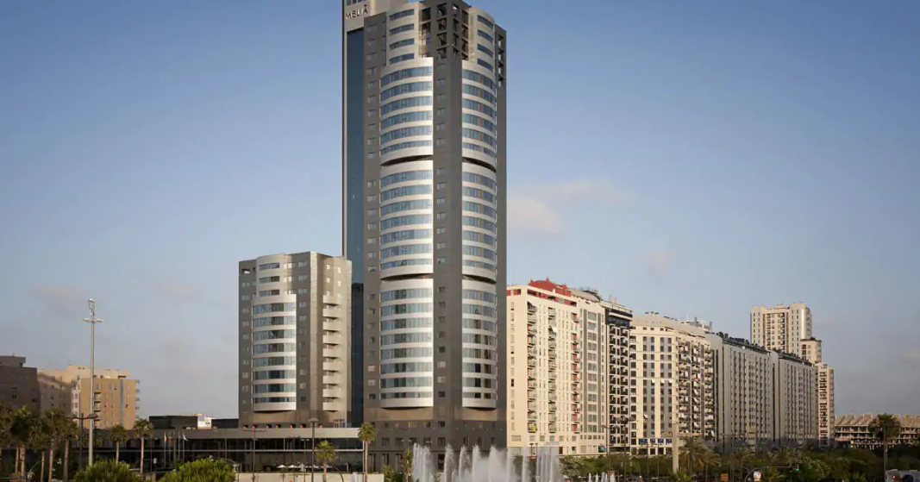

Transportation:
From the Valencia Airport to Meliá Valencia Hotel:

1. By taxi:
Estimated taxi cost: 20 euros approx. + 5.4 euros supplement fee from the airport.
Estimated time by taxi: 15 mins.

2. By metro:
Take Metro Line 3 or 5 at the airport (it is the first station for both lines). After ten stops, transfer in Àngel Guimerà Metro Station to Metro Line 1 (heading for Seminari-CEU or Bétera) or 2 (heading for Paterna or Lliria). In both cases, after three stops, you will get to Beniferri Station. This station is in the same avenue as Meliá Valencia Hotel. Just walk 5 minutes and you will reach the hotel at number 52.
Metro cost: 4.90 euros (3.90 euros + 1 euro for the travel card Móbilis).
Estimated time by metro: 30 mins.

