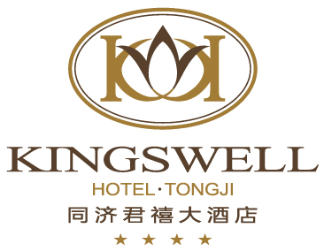

预定单
Reservation Form

□New 新单 □Amendment 修正单 □Cancellation 取消
*抵达Arrival Date： | *离开Departure Date：

Conf No.  确认号 | *Guest Name （Last Name/First Name）  客户姓名 | *Room Type  房间种类 | *Pax  数量 | Room Rate  房价（NO BKF） | Room Rate  房价(1 BKF) | Room Rate  房价(2 BKF)
 |  | Business Queen  标准大床房 |  | 468yuan/night  468元/晚 | 528yuan/night  528元/晚 | 558yuan/night  558元/晚
 |  | Superior Twin  标准双床房 |  | 468yuan/night  468元/晚 | 528yuan/night  528元/晚 | 558yuan/night  558元/晚
 |  | Club Room  行政楼大床房 |  | / | 628yuan/night  628元/晚 | 658yuan/night  658元/晚

Payment Method: Personal Account □ Credit Card number & valid month/year:
支付类型 个人支付 提供担保信用卡卡号&有效年/月：

Company Name公司名称 | *Contact Person联系人 | *Telephone No电话号码 | Email Add. 邮箱地址
Remarks：
备注： ________________________________________________________________________________________________

Reserved By： Date：
经办人： 日期：

以上价格包含15％的服务费。
The above rates inclusive of a 15% service charge.
所有预订酒店将保留至当晚18：00点，逾时预订将被自动取消。
除非您用信用卡担保承担预订未到费用，
所有担保预定取消必须提前72小时书面通知，否则酒店将收取一天房费。
Unless guaranteed by advance deposit/credit card, all reservations will be held until 18:00 p.m. local time.
One night “No Show” charge will apply to the credit card for guaranteed reservations,
which are not cancelled 72 hours prior to guest arrival.

同济君禧大酒店 Kingswell Hotel Tongji
地址：上海市杨浦区彰武路50号 Address: 50 Zhangwu Road,Yangpu District, 200092
电话Tel：（021）33626888*5188或33626868 传真Fax：（021）33626688
邮箱Email：junxi@kingswelltongji.com
如需其他任何讯息，请即与我们联络。
Please do not hesitate to contact us if you require further information.

